**Test Evidence: Valid login**

**Step: Given I navigate to OrangeHRM website [PASSED]**

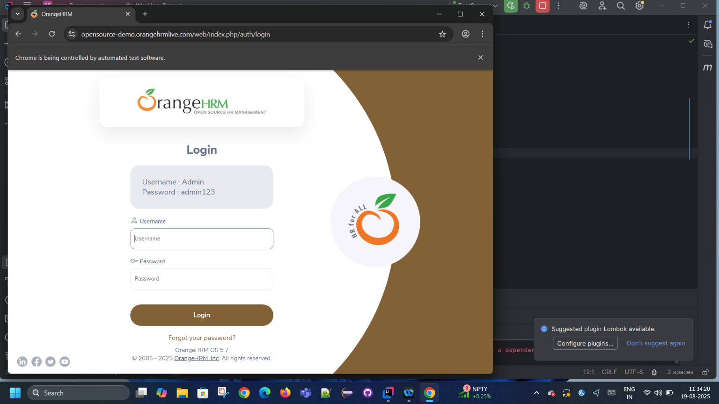

**Step: Given I navigate to OrangeHRM website1 [PASSED]**

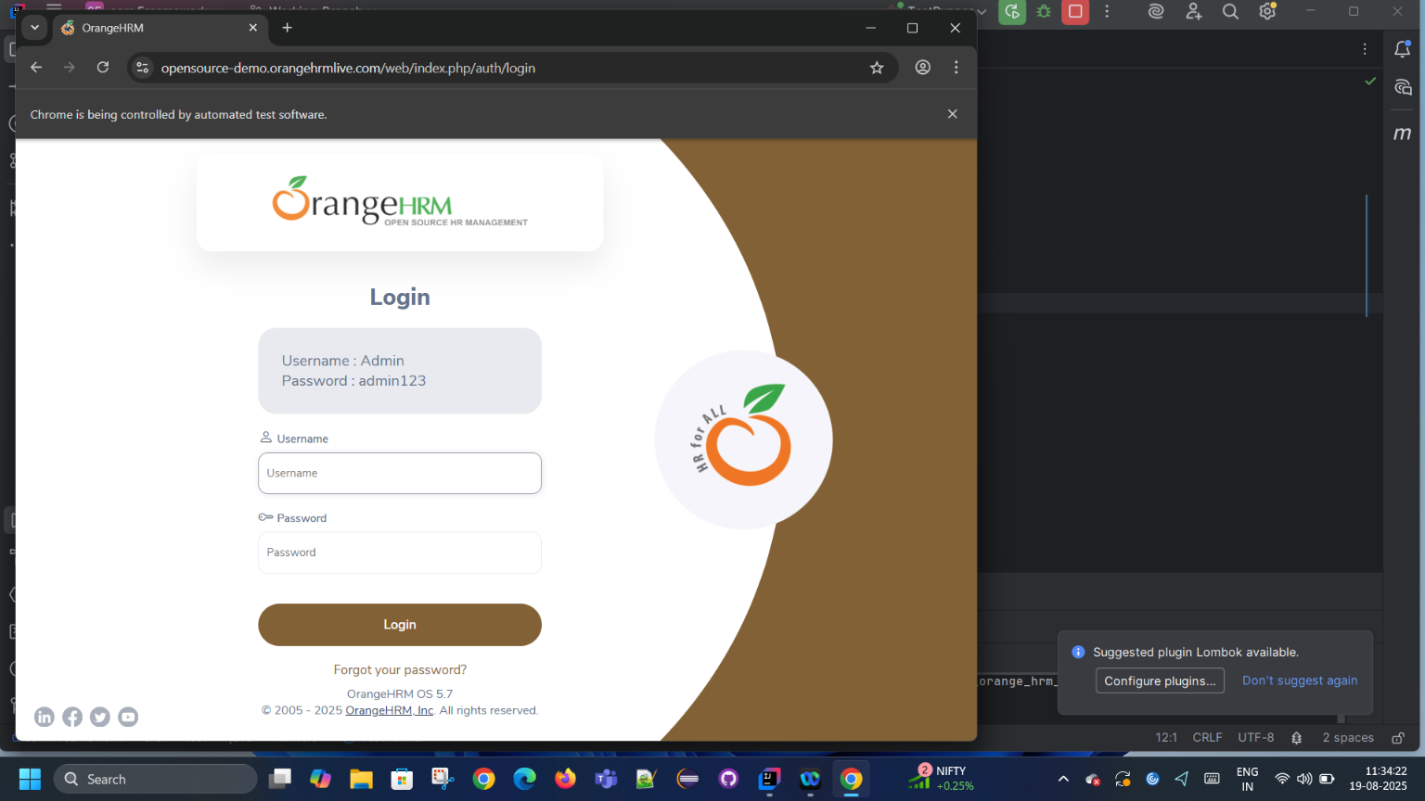

**Step: Given I navigate to OrangeHRM website2 [PASSED]**

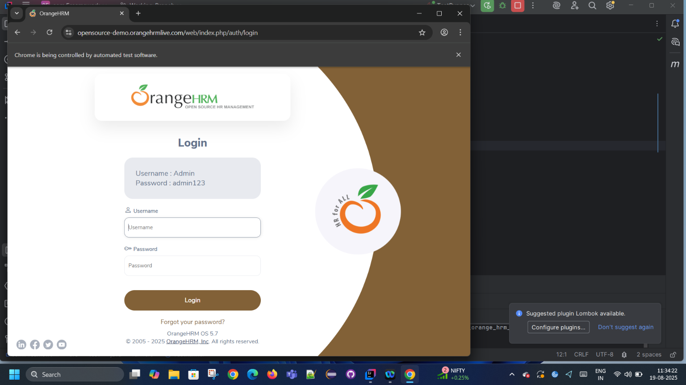

**Step: Given I navigate to OrangeHRM website3 [PASSED]**

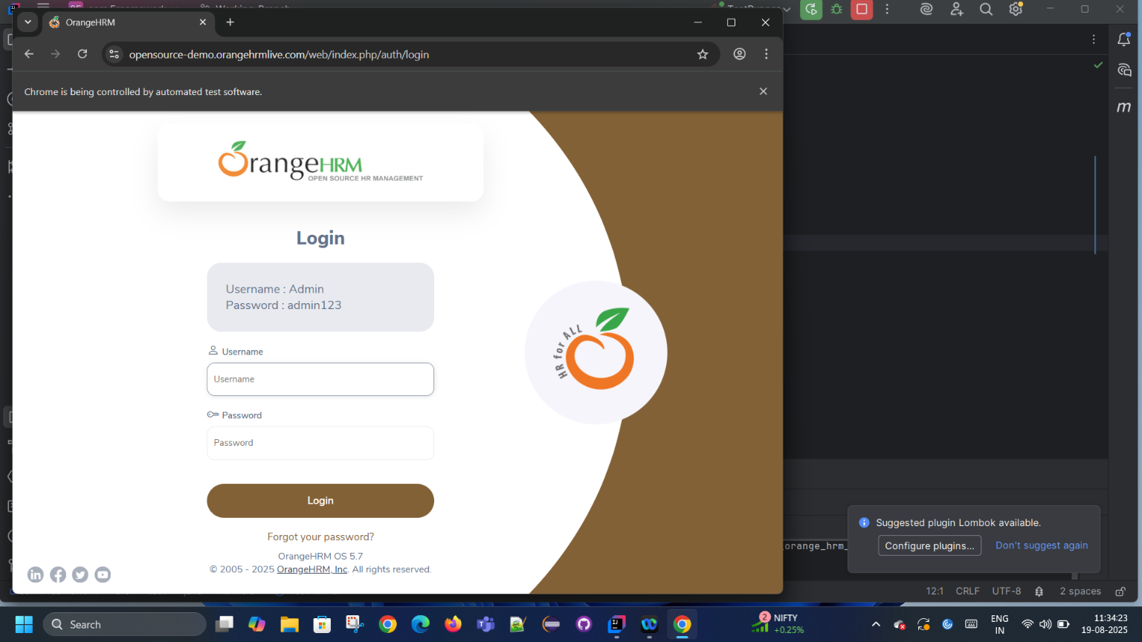

**Step: Given I navigate to OrangeHRM website4 [PASSED]**

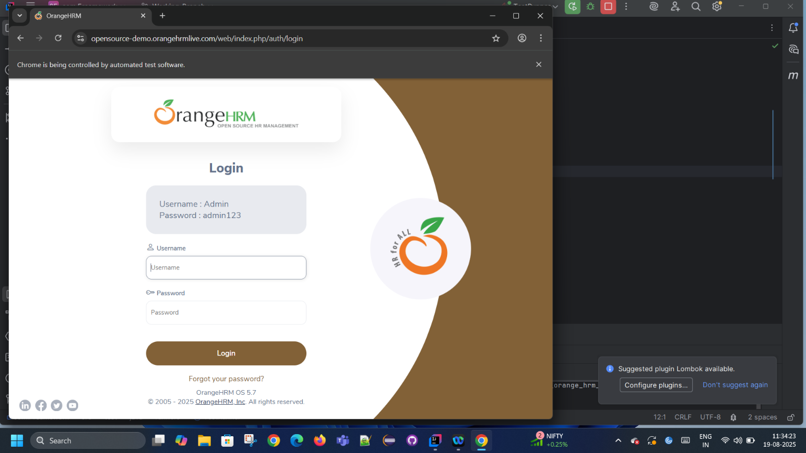

**Step: Given I navigate to OrangeHRM website5 [PASSED]**

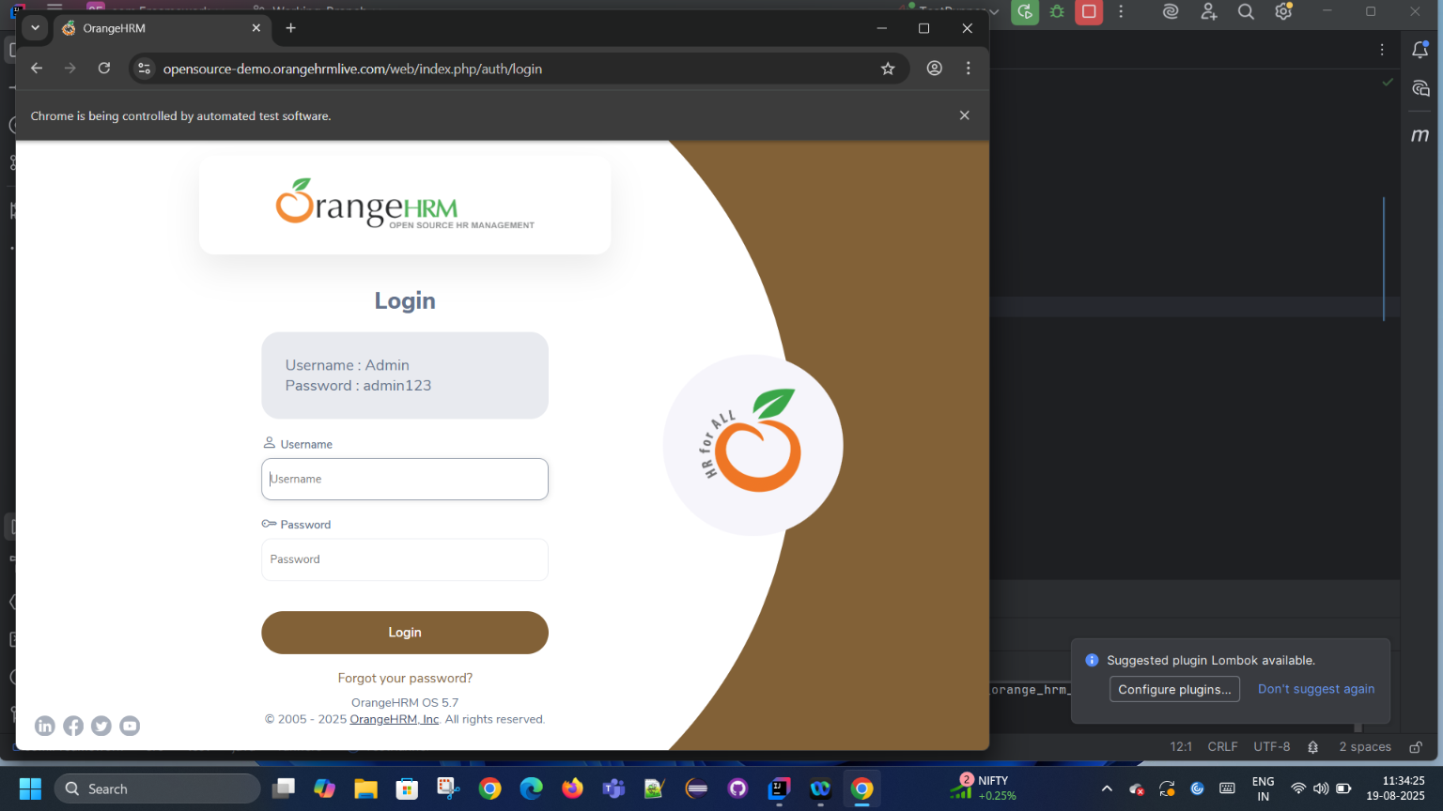

**Step: Given I navigate to OrangeHRM website6 [PASSED]**

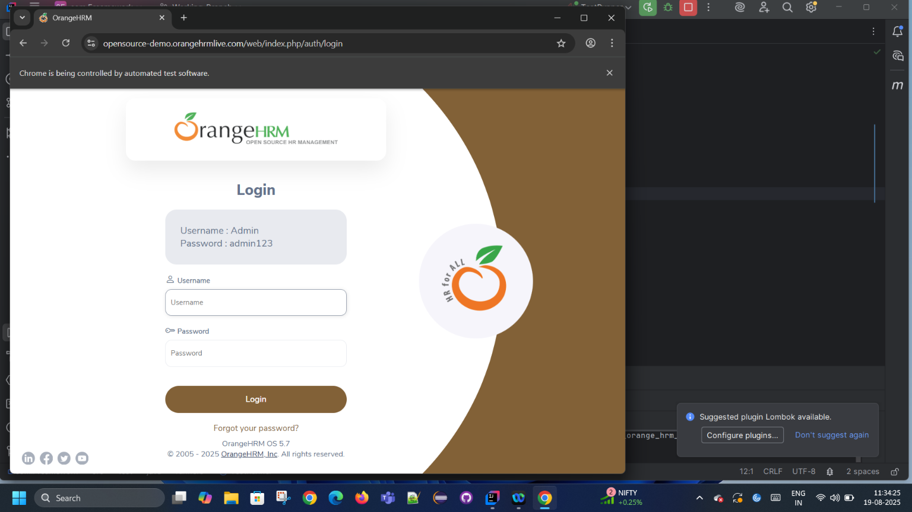

**Step: Given I navigate to OrangeHRM website7 [PASSED]**

